New Innovations and the ACGME Milestones

# School of Nursing Computer Lab, K4007

## Tuesday, November 5, 1 p.m.

## Thursday, November 7, 10 a.m. (note change from GME Calendar)

## Wednesday, November 13, 10 a.m.

# Objectives

* Clinical Competency Committee access to Milestones
  + Membership MUST be entered into Faculty Appointments
* The Milestone Semi-Annual Review (Portfolio Module)
* Evaluations and Milestones
  + Indirect (using current questionnaires)
  + Indirect (using new questionnaires)
  + Direct (using the milestones as the questions)

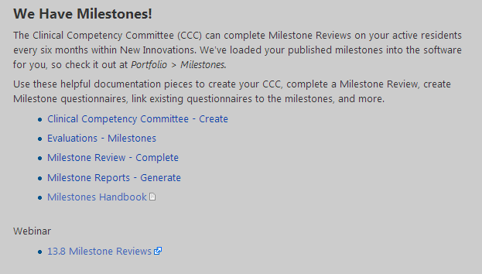

<http://www.acgme-nas.org/milestones.html>